Mosborough Primary School
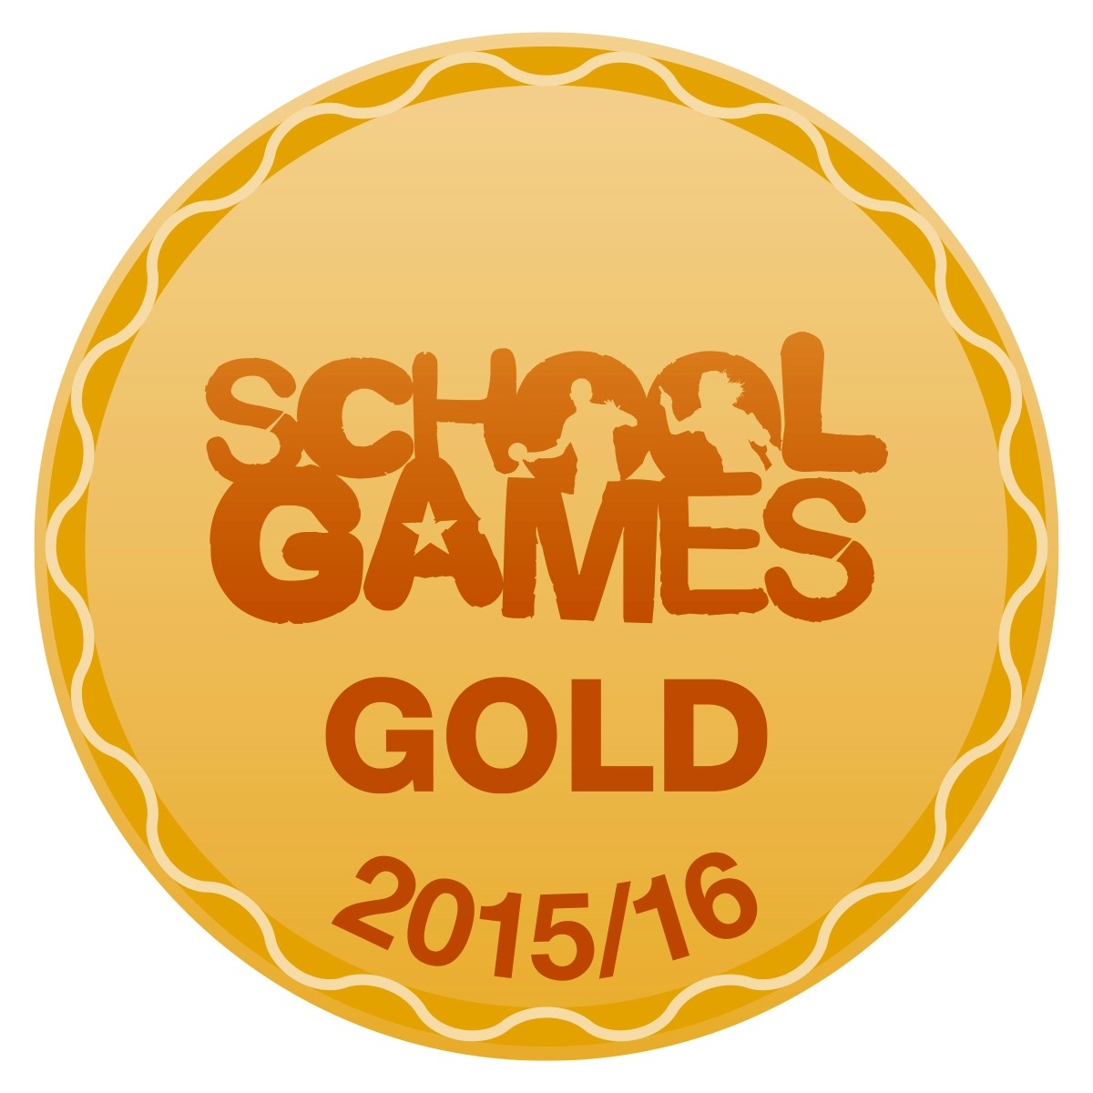

New School Road
Mosborough
Sheffield
S20 5ES
Tel: 0114 248 6211 Fax: 0114 2477121
Email:enquiries@mosborough.sheffield.sch.uk
Website: www.mosboroughprimary.co.uk

Online Safety

Dear Parents,

Next half term in school, we will be participating in ‘health week’. Whilst access to the internet is a fun way for children to be able to learn about their health and wellbeing, using the internet also involves risks and challenges, especially for children. There is lots of great information available to help protect children from potential harm over the internet.

Does the Internet affect your child’s mental health?
https://parentzone.org.uk/system/files/attachments/The%20Perfect%20Generation%20report_0.pdf

“A growing body of evidence suggests that online and offline resilience and vulnerability are linked. The young people we spoke to strongly agreed that the online world affects people differently depending on factors like their mood and their age – what one person might be able to brush off without much worry, others might find deeply disturbing.”

What is causing lack of body confidence and low self esteem?
Media Celebrities are airbrushed and 'improved' on the one hand and picked apart in the media on the other. We are bombarded by articles suggesting ways to improve our own looks.
Other social factors Family and friends can knowingly and unknowingly add to the pressure by teasing, bullying, accusing people of being fat and generally equating less-than-perfect looks with failure.
Biology It can be hard growing up - rapid body changes, visibly turning into a girl or a boy, developing faster or slower than your friends.
Psychology How young people feel about themselves can make a big difference to how they cope. Children with high self-esteem who don't compare themselves to others cope better. Those who believe they have to look perfect before they are entitled to expect equality, respect or appreciation - not surprisingly – find coping more difficult.

How can we help?
There are things that it is hard to alter as a parent - like the onslaught of media images and commentary – but some young people cope better than others.
- Remind your child that most pictures they see in the media have been airbrushed, manipulated or digitally enhanced, for example to make hair shinier or muscles more defined. Get them to talk about how they think this has been done; develop their media awareness.
- Be positive about your own body size and shape. Don't complain about your looks.
- Be accepting of other people's body sizes and shapes.
- Emphasise other attributes - both theirs and other people's. Talk up attitudes, skills, achievements, outlook.
- Don't be afraid to praise the physical attributes that make your child unique.
- Listen to their concerns about body image. Ask (sympathetically but without endorsing what they're saying) why they feel as they do; get them to dissect where these worries come from.
- Provide reassurance that they are loved and loveable just as they are and there is nothing 'wrong' with them.
- Encourage exercise - paradoxically, lack of body confidence often stops young people exercising. There is evidence that those who exercise feel better about themselves.
http://parentinfo.org/article/body-confidence-how-you-can-help – Full Article

NSPCC
https://www.nspcc.org.uk/preventing-abuse/keeping-children-safe/online-safety/

I wanted to take this opportunitiy to highlight some of the amazing work done by the NSPCC around Online Safety. The link above will take you to their web page where you will find a range of resources for both parents and children. Here are their four ‘top tips’ for keeping safe online:
  - Explore the online world together
  - Talk to your child about staying safe online
  - Manage the software and tools your family use
  - Agree rules about what’s ok and what’s not
Parent Workshop
To help you understand what the issues are and receive practical help, we are holding a parents and carers workshop in collaboration with the NSPCC (date and time to follow) Please come along to find out what the children at Mosborough have told us about being online and the risks it could present to them. If you have any specific questions regarding your child’s safety online, please bring them with you on the evening.

Online Safety Champions
We are in the process of recruiting 7 new Year 5 children to become Online Safety Champions at Mosborough. They will be reposible to ensuring children across all year groups access the internet safely and will also pariticipate in assemblies and launch competitions across school. Please check the Online Safety page on our school website for further updates on this!

Further Information (Health and Well-being):
Here are some more websites where you can find excellent information linked with Online-Safety. Most of these are both adult and child friendly:

https://www.internetmatters.org/parental-controls/devices-computers/ - What is good screen time?
http://vodafonedigitalparenting.co.uk/useful-tools/childs-eye-health/ - Eye Health
http://vodafonedigitalparenting.co.uk/expert-advice/technology-childs-health/ - Technology and Health links
http://parentinfo.org/article/eating-disorders-and-the-internet – Eating Disorders and the Internet
http://www.mtv.co.uk/life/news/time-to-talk-our-fave-vloggers-on-mental-health – Vloggers discuss mental health

Please do not hesitate to ask any further questions and remember to check the Online Safety Page on the school website for further resources.

Yours

Miss Sanderson

